
Safety Bay Senior High School
Chemistry Unit 1 & 2

Test #2:
Atomic Theory & Matter

NAME: ______________________________________

Reading time: 5 minutes
Working time: 55 minutes

Section | Mark
Multiple Choice | / 10
Short Answer | / 45
Total | / 55

MULTIPLE CHOICE 10 marks

- What determines the type of element that an atom will be?

  - Its electric charge
  - Its electron configuration
  - Its number of neutrons
  - Its number of protons

- A particular atom is represented with the following atomic symbol: ${}_{7}^{15}X$

Which of the following is the correct electron configuration for Element X?

  - 2, 5
  - 2, 6
  - 2, 7
  - 2, 8, 5

- Element M is a metallic element which forms positive ions. The formula of a chloride salt of Element M is MCℓ₂. What is the formula of a sulfate salt of M?

  - MSO₄
  - M₂SO₄
  - M(SO₄)₂
  - M₂(SO₄)₃

- Element A has an electron configuration of 1s² 2s² and Element B has an electron configuration of 1s² 2s² 2p⁵. What will be the most likely formula of the compound formed between these two elements?

  - AB
  - AB₂
  - A₂B
  - AB₃

- Which of the following arranges elements in order of increasing ionisation energy?

  - F < Mg < Si < S
  - F < S < Si < Mg
  - Mg < S < Si < F
  - Mg < Si < S < F

- Which of the following statements gives the meaning of ‘electronegativity’?

  - The ability of an atom to accept an electron to form a negatively charged ion
  - The ability of an atom to attract electrons and form bonds with electrons
  - The energy required to remove an electron from the atom in the gas phase
  - The energy released when an electron is added to the atom in the gas phase

- A polar covalent bond is a bond formed when two atoms with different electronegativities share a pair of electrons. The larger the difference in electronegativity, the greater the polarity of the bond.

Which combination of atoms would form the most polar bond?

  - Two fluorine atoms bonded together
  - A fluorine atom and an iodine atom
  - A fluorine atom and a bromine atom
  - A fluorine atom and a chlorine atom

- The following diagram shows emission spectra for four elements and an unknown sample.

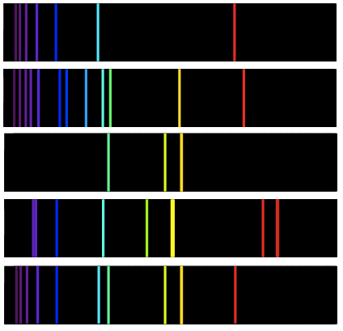
Helium:
Hydrogen:
Sodium:
Mercury:
Unknown:

Which option in the table below correctly identifies whether or not hydrogen, helium, sodium and mercury are present in the unknown sample?

 | Hydrogen | Helium | Sodium | Mercury
(a) | x | ✔ | x | x
(b) | ✔ | x | ✔ | x
(c) | x | ✔ | ✔ | x
(d) | ✔ | ✔ | ✔ | x

- Which of the following best describes the composition and properties of a pure substance?
 | Composition | Physical and chemical properties
(a) | Homogeneous | Constant
(b) | Homogeneous | Variable
(c) | Heterogeneous | Constant
(d) | Heterogeneous | Variable

- A mixture of methanol and water can be separated by simple distillation (diagram of apparatus shown below). Methanol has a boiling point of 67 °C and water has a boiling point of 100 °C.

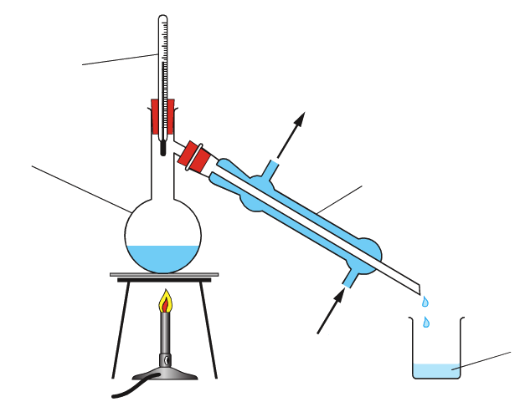
Thermometer
Condenser
Beaker
Round-bottom flask
Cool water in
Cool water out

Which of the following correctly describes the distillate in this procedure?

  - The distillate is pure water, and it is collected in the beaker
  - The distillate is pure water, and it remains in the round-bottom flask
  - The distillate is pure methanol, and it is collected in the beaker
  - The distillate is pure methanol, and it remains in the round-bottom flask

SHORT ANSWER 45 marks
- (4 marks)

- Write the formulas of the following compounds: (2 marks)

  - Sodium permanganate:

  - Zinc hydroxide:

- Write the names of the following compounds: (2 marks)

  - SF₂:

  - CuI₂ :

- (5 marks)

Submarines and spacecraft generate oxygen by the decomposition of potassium chlorate, KCℓO₃. This decomposition reaction is shown below:

2 KCℓO₃ (s) 2 KCℓ (s) + 3 O₂ (g)

- What does the formula KCℓO₃ indicate about the relative numbers of atoms in the compound?
(1 mark)

- What mass of oxygen gas would be produced from the decomposition of 138.6 g of KCℓO₃? Show all working and give your final answer to three significant figures. (4 marks)

- (6 marks)

- Compare and contrast the charge and relative mass of protons and neutrons. (2 marks)

- Within the nucleus there are both attractive forces and repulsive forces. In the table below:
- Give the names of the attractive and repulsive forces in the nucleus (2 marks)
- Draw arrows on the diagram to show which particles the forces act between. (2 marks)

 | Attractive force | Repulsive force
Name of force
Diagram representation | p  n  n  p | p  n  n  p

- (2 marks)

- What does the value of an atom’s relative atomic mass (A_{r}) indicate? (1 mark)

- Tin has a relative atomic mass of 118.7 according to the periodic table, but no single atom of tin has a relative atomic mass of 118.7. Account for this difference. (1 mark)

- (2 marks)

Complete the following table:

Symbol (${}_{\text{Z}}^{\text{A}}{\text{X}}$) | Atomic number | Mass number | Number of protons | Number of neutrons
$${}_{\text{42}}^{\text{95}}{\text{Mo}}$$
 | 47 | 109

- (5 marks)

- Give the common names for elements in Group 17 and Group 18 on the Periodic Table. (2 marks)

Group 17:

Group 18:

- What criteria is used to sort elements on the periodic table from left to right? (1 mark)

- Elements in the same group of the periodic table share the same number of valence electrons, but the current layout of the periodic table was constructed prior to our understanding of electron configurations and valence electrons.
What criteria was used to arrange elements into groups before the existence of valence electrons was known? Give an example to support your answer. (2 marks)

- (4 marks)

The periodic table shows trends in ionisation energy, electronegativity, electron affinity and atomic radius.

- Define ionisation energy. (1 mark)

- State and explain the trend in atomic radius as you go across Period 2. (3 marks)

- (4 marks)

Electron configurations can be represented using either the shell model (e.g. Hydrogen has a shell configuration of 1) or the sub-shell model (e.g. Hydrogen has a sub-shell configuration of 1s¹).

Complete the table to show the electron configurations of nitrogen and potassium using each method.

Element | Electron configuration
 | Shell model | Sub-shell model
Nitrogen
Potassium

- (5 marks)
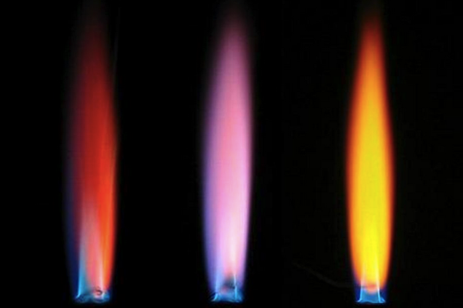
A flame test is a practical test which involves heating a metal salt directly on a flame. The salts give off different coloured light resulting in different coloured flames. This is the same principle behind the operation of fireworks, which contain similar types of metal salts.
The photograph to the right demonstrates this process. The three salts in the flames are (left to right):
Calcium chloride, potassium nitrate, sodium chloride.

- Write the chemical formulas for calcium chloride and potassium nitrate. (1 mark)

Calcium chloride:

Potassium nitrate:

- Explain why metal salts give off certain colours of light when heated by the flame. (2 marks)

- Explain why the flame colour for sodium chloride is different to the flame colour for calcium chloride.
(2 marks)

- (3 marks)

- Classify the following substances by listing them in the correct columns in the table below.

- Iodine
- Wine
- Blood
- NaCℓ (aq)
- CaO (s)
- P₄ (s)

Pure substance |  | Mixture
Element | Compound | Homogeneous | Heterogeneous
…………………....  …………………....  ………………….... | …………………....  …………………....  ………………….... | …………………....  …………………....  ………………….... | …………………....  …………………....  …………………....

- (5 marks)

Kerosene and ethanol are two immiscible liquids. The properties of these liquids are described below.

 | Ethanol | Kerosene
Boiling point | 78 °C | 150 °C
Density | 789 kg/m³ | 810 kg/m³
Colour | Colourless | Colourless
Reactivity | Flammable | Flammable

- List a separating technique that will separate these substances based on boiling point. (1 mark)

- List a separating technique that will separate these substances based on density and solubility.
(1 mark)

- If you were required to separate these substances in class, which of the above methods would you use? Justify your answer by listing three advantages of your chosen method. (3 marks)

SPARE WORKING PAGE
If you use this page to continue an answer from a previous question, you must indicate near the question that your answer continues on this page. If you do not indicate this then the answer on this page will not be marked.

SPARE WORKING PAGE (CONTINUED)
If you use this page to continue an answer from a previous question, you must indicate near the question that your answer continues on this page. If you do not indicate this then the answer on this page will not be marked.

